**COMPILE MATE**

**A Mini Project Report**

**Submitted in Partial fulfillment for the award of**

**Bachelor of Technology in Computer Science & Engineering**

Submitted to

**RAJIV GANDHI PROUDYOGIKI VISHWAVIDYALAYA**

**BHOPAL (M.P)**



**MINI PROJECT REPORT**

Submitted by

Samagra Agarwal [0103CS211155] Sarabpreet Singh [0103CS211161]

Shamshuddin [0103CS211165]

Under the supervision of

**Prof. Rahul Sahu**

Professor



**Department of Computer Science & Engineering**

**Lakshmi Narain College of Technology, Bhopal (M.P.)**

**Session 2022-23   
  
https://colab.research.google.com/drive/1GRBVKk9DjoNnn8tHaP9J7L1t0sKUeNFV?usp=sharing**



**LAKSHMI NARAIN COLLEGE OF TECHNOLOGY, BHOPAL**

**DEPARTMENT OF COMPUTER SCIENCE & ENGINEERING**

### **CERTIFICATE**

### 

This is to certify that the work embodied in this project work entitled **”COMPILE MATE”** has been satisfactorily completed by the **Samagra Agrawal** [0103CS211155], **Sarabpreet Singh** [0103CS211161] , **Shamshuddin** [0103CS211165] .It is a bonafide piece of work, carried out under the guidance in **Department of Computer Science & Engineering**, **Lakshmi Narain College of Technology, Bhopal** for the partial fulfillment of the **Bachelor of Technology** during the academic year 2022-23.

**Guided By**

**Prof. Rahul Sahu**

Professor

**Approved By**

**Dr. Sadhna K. Mishra**

**Prof. & Head**

# **Department of Computer Science & Engineering**



**LAKSHMI NARAIN COLLEGE OF TECHNOLOGY, BHOPAL**

**DEPARTMENT OF COMPUTER SCIENCE & ENGINEERING**

**Acknowledgement**

We express our deep sense of gratitude to Prof. Rahul Sahu department of Computer Science & Engineering L.N.C.T., Bhopal. Whose kindness valuable guidance and timely help encouraged me to complete this project.

A special thank goes to Dr. Sadhna K. Mishra (HOD) who helped me in completing this project work. She exchanged her interesting ideas & thoughts which made this project work successful.

We would also thank our institution and all the faculty members without whom this project work would have been a distant reality.

Samagra Agrawal [0103CS211155]

Sarabpreet Singh [0103CS211161]

Shamshuddin [0103CS211165]

**S.NO. TOPICS PAGES**

1. **Introduction 5**
2. **Literature Survey 6-8**
3. **Mini objective & scope of project 9-10**
4. **Problem Analysis and requirement specification 11-18**
5. **Detailed Design(Modeling and ERD/DFD ) 19-20**
6. **Hardware/Software platform environment 21-22**
7. **Snapshots of Input & Output 23-25**
8. **Coding 26-28**
9. **Project limitation and Future scope 29-30**
10. **References 31**

**CHAPTER 1**

**INTRODUCTION**

The field of software development is rapidly evolving, with an increasing number of developers relying on online Integrated Development Environments (IDEs) to write, edit, and test their code. Online IDEs offer the advantage of accessibility, collaboration, and convenience, allowing developers to work on their projects from anywhere with an internet connection. In line with this trend, the "Compile Mate" project aims to develop a robust and user-friendly web-based IDE to cater to the needs of modern developers.

"Compile Mate" is an innovative web application that provides developers with a comprehensive coding environment accessible through a web browser. It leverages a combination of HTML, CSS, JavaScript, Node.js, Express.js, Bootstrap, CodeMirror, and CodexApi to deliver a seamless coding experience. The IDE offers a wide range of features, including code editing, syntax highlighting, error checking, code execution, collaboration tools, version control integration, and user authentication.

**Motivation:**

The motivation behind the development of "Compile Mate" stems from the growing demand for efficient and accessible coding tools. Traditional desktop-based IDEs often require extensive setup, installation, and updates, limiting their portability and collaboration capabilities. By providing a web-based IDE, "Compile Mate" eliminates the need for complex installation processes and allows developers to work on their projects from any device with an internet connection. The project aims to empower developers, regardless of their location or hardware constraints, by offering a powerful coding environment that fosters productivity and collaboration.

**CHAPTER 2**

**LITERATURE SURVEY**

**1. Cloud9:** Cloud9 is a popular cloud-based IDE that offers a comprehensive set of features for web development. It provides a collaborative coding environment, allowing multiple users to work on the same project simultaneously. Cloud9 supports various programming languages, code highlighting, code completion, and built-in terminal access. It also integrates with version control systems like Git, providing seamless collaboration and project management capabilities.

**2. Repl.it:** Repl.it is an online coding platform that offers a fully-featured IDE for a wide range of programming languages. It provides an intuitive interface, syntax highlighting, code execution, and live collaboration features. Repl.it supports the creation and sharing of code snippets, making it ideal for quick prototyping and sharing code examples. It also integrates with popular version control systems and provides deployment options for hosting web applications.

**3. Codeanywhere:** Codeanywhere is a cloud-based IDE that allows developers to write, edit, and run code from any device with internet access. It supports a multitude of programming languages, offering syntax highlighting, code completion, and integrated terminal access. Codeanywhere also supports collaboration, enabling real-time collaboration on code projects with team members.

**4. CodeSandbox:** CodeSandbox is an online IDE specifically designed for web application development. It provides an environment where developers can build, test, and deploy web applications directly from the browser. CodeSandbox supports popular web development frameworks like React, Vue.js, and Angular. It offers features like live previews, code sharing, and integration with version control systems.

**5. Visual Studio Online:** Visual Studio Online is the cloud-based version of Microsoft's popular Visual Studio IDE. It offers a rich set of features for code editing, debugging, and collaboration. Visual Studio Online supports a wide range of programming languages and provides seamless integration with Azure services for easy deployment and hosting of applications. It also offers real-time collaboration and version control integration.

**6. JSFiddle:** JSFiddle is a web-based coding playground that allows developers to experiment, test, and share HTML, CSS, and JavaScript code snippets. It provides a simple and minimalistic interface for quickly prototyping and sharing code examples. JSFiddle supports real-time collaboration, allowing multiple users to work on the same code snippet simultaneously.

**7. GitPod:** GitPod is an online IDE designed specifically for GitHub projects. It provides an automated development environment for each Git branch, allowing developers to start coding instantly without worrying about environment setup. GitPod integrates seamlessly with GitHub and provides powerful features like code completion, debugging, and collaboration tools.

**8. CoderPad:** CoderPad is an online IDE primarily used for conducting technical interviews. It offers a collaborative coding environment with features like code highlighting, code execution, and a built-in collaborative text editor. CoderPad supports multiple programming languages and provides a seamless interview experience for both interviewers and candidates.

**9. CodePen:** CodePen is a popular online code editor that focuses on front-end web development. It allows developers to write HTML, CSS, and JavaScript code in separate panels and instantly see the results in the preview panel. CodePen supports collaboration, code sharing, and provides an extensive collection of user-created code snippets and projects.

**10. Glitch:** Glitch is an online coding platform that focuses on creating and hosting web applications. It offers a collaborative coding environment, real-time collaboration, and deployment options. Glitch supports various programming languages and provides an easy-to-use interface for quickly building and sharing web applications.

The above literature survey provides insights into different online IDEs and

coding platforms available in the market. These platforms have contributed to the development of "Compile Mate" by offering ideas and best practices in terms of user interface design, collaboration features, code editing capabilities, integration with version control systems, and deployment options. By analyzing and understanding these existing solutions, the "Compile Mate" project aims to provide a comprehensive and user-friendly online IDE experience to developers.

**CHAPTER 3**

**MINI OBJECTIVES & SCOPE OF PROJECT**

**Objectives**

The "Compile Mate" project is driven by the following mini objectives:

**Objective 1:** Develop a User-Friendly Web-Based IDE The primary objective of "Compile Mate" is to create a user-friendly web-based IDE that provides developers with a seamless coding experience. The IDE should have an intuitive and easy-to-use interface, allowing users to write, edit, and manage their code efficiently. Emphasis will be placed on providing a clean and responsive design that enhances the overall user experience.

**Objective 2:** Support Multiple Programming Languages "Compile Mate" aims to cater to the needs of developers working with different programming languages. The IDE will be designed to support a wide range of programming languages, including popular ones like Python, JavaScript, Java, C++, and more. This objective ensures that developers have the flexibility to work with their preferred programming language within the IDE.

**Objective 3:** Code Editor with Advanced Features The IDE in "Compile Mate" will include a feature-rich code editor. It will provide advanced features such as syntax highlighting, code autocompletion, code folding, and error checking. These features enhance code readability, productivity, and help identify and fix syntax errors or potential bugs in real-time.

**Objective 4:** Integration with Code Execution Environment "Compile Mate" will integrate with CodexApi, a reliable and secure code execution API. This integration will enable users to compile and run their code directly within the IDE environment. Developers can expect a seamless coding experience without the need for setting up local development environments, ensuring convenience and efficiency.

**Objective 5:** Collaboration and Version Control To facilitate collaboration among developers, "Compile Mate" will include collaboration features. Users will be able to work on team projects, share code snippets, and communicate effectively within the IDE. Additionally, integration with popular version control systems like Git will be provided, allowing users to manage their code repositories, track changes, and collaborate with team members efficiently.

**Objective 6:** User Authentication and Authorization To ensure secure access and protect user data, "Compile Mate" will implement user registration, authentication, and authorization mechanisms. Users will be able to create accounts, log in securely, and manage their profiles within the IDE. This objective aims to provide a secure and personalized coding environment for each user.

**Scope of the Project :-**

The scope of the "Compile Mate" project encompasses the development of the core IDE functionalities along with additional features. These features include syntax highlighting, error checking, collaboration tools, version control system integration, and user authentication and authorization. The project will focus on ensuring a seamless and efficient coding experience for developers working with various programming languages.

It's important to note that while the initial version of "Compile Mate" will provide a solid foundation for online coding, there may be additional features and enhancements that can be considered in future iterations. The scope of the project may expand to include advanced code editing features, real-time collaboration, debugger integration, integration with external APIs and libraries, deployment and hosting support, enhanced security measures, and mobile application development.

By focusing on these mini objectives and scope, "Compile Mate" aims to provide developers with a powerful and user-friendly online IDE that meets their coding needs and enhances their productivity and collaboration capabilities.

**CHAPTER 4**

**PROBLEM ANALYSIS AND**

**REQUIREMENT SPECIFICATION**

**1. Introduction**

An online compiler is a software tool that allows users to write, compile, and execute code from a web browser. This SRS document outlines the features and functionalities of an online compiler.

**2. Functional Requirements**

**2.1 User Authentication and Registration**

The online compiler should have a user authentication and registration system to allow users to create accounts and log in to the system. The system should also provide a password reset functionality.

**2.1.1 Registration:**

- Users should be able to create a new account by providing a unique email address and password.

- Users should receive a confirmation email to verify their account.

**2.1.2 Login:**

- Users should be able to log in to their account using their email address and password.

- Users should be able to stay logged in for a certain period of time, using session cookies or similar.

**2.1.3 Password reset:**

- Users should be able to reset their password if they forget it.

- Users should receive an email with a password reset link that expires after a certain period of time.

**2.2 Code Editor**

The online compiler should provide a code editor that supports multiple programming languages. The editor should provide syntax highlighting, auto-indentation, code completion, and error highlighting.

**2.2.1 Language Support:**

- The online compiler should support multiple programming languages, such as Java, C++, Python, Ruby, and others.

- The code editor should provide syntax highlighting, auto-indentation, code completion, and error highlighting for each language.

**2.2.2 Code Editor Features:**

- The code editor should allow users to copy, paste, cut, and undo/redo their code.

- The editor should also support line numbering and cursor placement.

**2.3 Compilation**

The online compiler should be able to compile source code in real-time. The system should compile the code and return the results to the user.

**2.3.1 Compilation Process:**

- The online compiler should compile the user's code when the "Compile" button is clicked.

- The system should check the code for syntax errors and report them to the user.

**2.3.2 Compilation Status:**

- The online compiler should display the compilation status, such as "Compilation successful" or "Compilation failed."

- The compiler should provide a log of the compilation process, including any errors or warnings.

**2.4 Execution**

The online compiler should be able to execute the compiled code. The system should provide a virtual environment for executing the code to ensure that it does not affect the host system.

**2.4.1 Execution Environment:**

- The online compiler should provide a virtual environment for executing the user's code.

- The system should limit the resources used by the code, such as CPU time and memory, to prevent malicious or inefficient code from impacting the host system.

**2.4.2 Execution Status**:

- The online compiler should display the execution status, such as "Execution successful" or "Execution failed."

- The system should provide a log of the execution process, including any errors or warnings.

**2.5 Output Display**

The online compiler should provide an output display to show the results of the compiled and executed code. The output display should show the standard output, standard error, and any other relevant messages.

**2.5.1 Output Display:**

- The online compiler should display the standard output and standard error generated by the user's code.

- The system should also display any other relevant messages, such as runtime errors or exceptions.

**2.6 Input Functionality**

The online compiler should allow users to provide input to the compiled and executed code.

**2.6.1 Input:**

- The online compiler should provide a way for users to input data to the compiled and executed code.

- The input mechanism should support different types of input, such as text, numbers, and files.

**2.7 Saving and Sharing Code:**

The online compiler should provide a way for users to save and share their code with others.

**2.7.1 Saving Code:**

- The online compiler should allow users to save their code to their account or to their local machine.

- Users should be able to give their code a name and description.

**2.7.2 Sharing Code:**

- The online compiler should allow users to share their code with others through a unique URL.

- Users should be able to set the privacy settings for their code, such as making it public or private.

**3. Non-functional Requirements**

**3.1 Performance**

The online compiler should be fast and responsive. The system should compile and execute code in real-time, without any noticeable delay.

**3.2 Scalability**

The online compiler should be able to handle a large number of users simultaneously. The system should be able to scale up or down as needed to meet the demand.

**3.3 Security** The online compiler should be secure and protect user data and code. The system should prevent unauthorized access and protect against attacks such as cross-site scripting and SQL injection.

**3.4 Usability**

The online compiler should be easy to use and navigate. The system should have a user-friendly interface with clear and concise instructions.

**4. Constraints**

**4.1 Browser Compatibility** The online compiler should be compatible with popular web browsers such as Google Chrome, Mozilla Firefox, and Microsoft Edge.

**4.2 Hardware Requirements** The online compiler should run on standard hardware and should not require any specialized equipment or software.

**5. Assumptions and Dependencies**

**5.1 Assumptions**

Users have a basic understanding of programming languages and concepts.

Users have a stable internet connection.

**5.2 Dependencies**

The online compiler depends on third-party libraries and tools for language support and compilation.

The system depends on a stable and reliable hosting environment.

**6. System Architecture**

**6.1 Overview**

The online compiler system will consist of several components that work together to provide the necessary functionality. The following diagram provides an overview of the system architecture:

**6.2 Components**

The system architecture will consist of the following components:

**6.2.1 User Interface**

The user interface will provide a way for users to interact with the system. Users will be able to write, compile, and execute code, as well as view the output and errors.

**6.2.2 Code Editor**

The code editor will provide a text editor with syntax highlighting for various programming languages. Users will be able to write and edit code in the editor.

**6.2.3 Compiler**

The compiler will be responsible for compiling the user's code. The system will support multiple programming languages, and the compiler will be responsible for compiling the code into executable code.

**6.2.4 Execution Environment**

The execution environment will be responsible for executing the compiled code. The system will provide a secure sandbox environment for executing the code to prevent unauthorized access to the system.

**6.2.5 Input/Output Handler**

The input/output handler will be responsible for handling input and output to the compiled and executed code. The system will support various types of input and output, such as text, numbers, and files.

**6.2.6 Database** The database will be responsible for storing user data, such as saved code and user settings. The database will also be used to store user authentication and authorization information.

**7. User Interface Design**

The user interface should be intuitive and easy to use. The following diagram provides a mock-up of the user interface:

The user interface will consist of the following components:

**7.1 Header**

The header will contain the logo and navigation links to different sections of the website.

**7.2 Code Editor**

The code editor will provide a text editor with syntax highlighting for various programming languages.

**7.3 Input Section**

The input section will allow users to input data to the compiled and executed code. The input mechanism should support different types of input, such as text, numbers, and files.

**7.4 Output Section**

The output section will display the output and errors generated by the compiled and executed code.

**7.5 Controls**

The controls section will contain buttons for compiling, executing, and saving code.

**7.6 Footer**

The footer will contain copyright information and links to the privacy policy and terms of use.

**8. Testing Requirements**

**8.1 Unit Testing**

Unit testing should be performed on each component of the system to ensure that it functions correctly.

**8.2 Integration Testing**

Integration testing should be performed to ensure that the components of the system work together correctly.Acceptance testing should be performed to ensure that the system meets the requirements outlined in this SRS document.

**9. Maintenance and Support**

**9.1 Maintenance**

The online compiler system should be regularly maintained to ensure that it remains up-to-date and secure.

**9.2 Support**

The system should provide support to users who encounter issues while using the system. Support should be available through email, phone, or online chat.

**10. Conclusion**

This SRS document has outlined the requirements for an online compiler system. The system should allow users to write, compile, and execute code in various programming languages. The system should be fast, scalable, and secure, with an intuitive and user-friendly interface. Regular maintenance and support should be provided to ensure that the system remains up-to-date and functional.The online compiler should be compatible with popular web browsers such as Google Chrome, Mozilla Firefox, and Microsoft Edge.

**CHAPTER 5**

**DETAILED DESIGN**

**(MODELLING & ERD/DFD)**

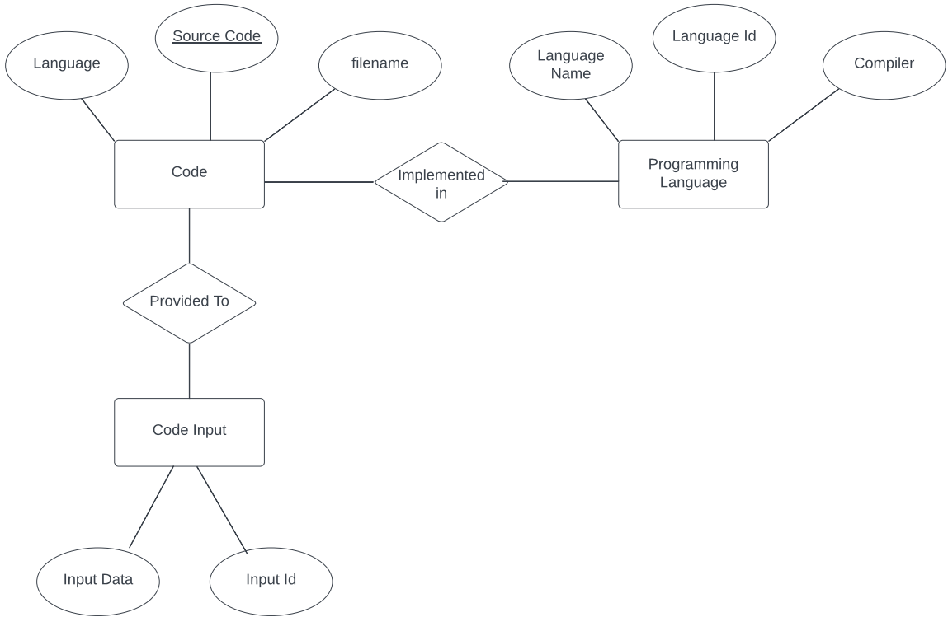

Entity Relationship Diagram (ERD)

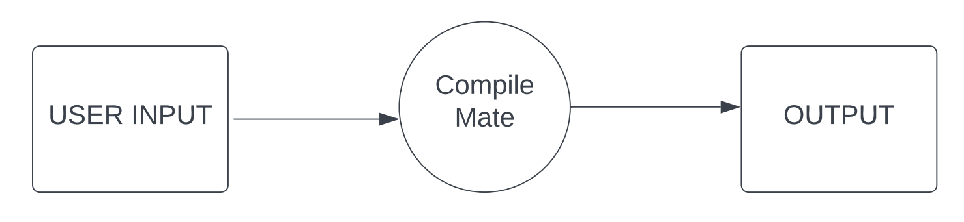

Level-0 DFD

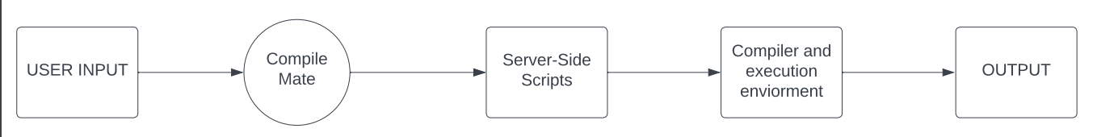

Level-1 DFD

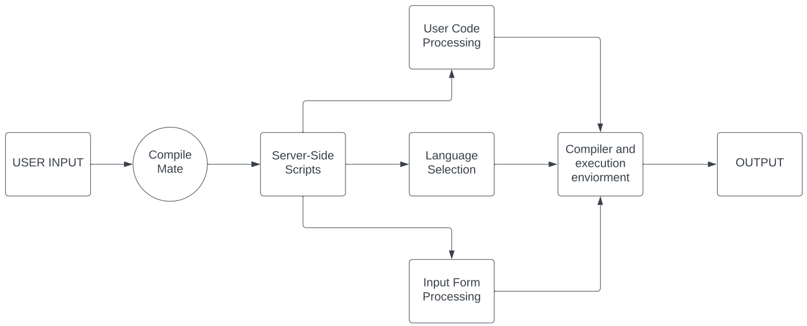

Level-2 DFD

**CHAPTER 6**

**HARDWARE/SOFTWARE**

**PLATFORM ENVIRONMENT**

The successful deployment and operation of the "Compile Mate" web application require the following hardware and software components:

**Hardware:**

**1. Server Infrastructure:** The "Compile Mate" application will require a robust server infrastructure to host and serve the web application to users. The server should have sufficient computational power, memory, and storage capacity to handle multiple user requests concurrently and ensure smooth performance. Additionally, the server infrastructure should have reliable network connectivity to ensure uninterrupted access to the application.

**2. Storage:** Adequate storage capacity is crucial for the "Compile Mate" application to store user data, code snippets, project files, and associated resources. The storage solution should be scalable, secure, and performant to handle the increasing amount of data generated by users. Additionally, appropriate backup mechanisms should be in place to ensure data integrity and disaster recovery.

**3. Networking:** A stable and reliable network infrastructure is essential for users to access the "Compile Mate" web application seamlessly. The network should provide sufficient bandwidth and low latency to ensure fast response times and smooth user experience. Additionally, appropriate network security measures, such as firewalls and encryption, should be implemented to protect user data and ensure the confidentiality and integrity of communications.

**Software:**

**1. Operating System:** The "Compile Mate" application can be deployed on any modern operating system that supports Node.js and Express.js, such as Linux, Windows, or macOS. The choice of the operating system should consider factors like performance, security, compatibility, and ease of administration.

**2. Node.js:** Node.js is a JavaScript runtime environment that allows server-side execution of JavaScript code. It provides the foundation for running the "Compile Mate" application on the server. Node.js offers excellent performance and scalability, making it suitable for handling concurrent user requests. It also provides a vast ecosystem of modules and libraries that can be utilized to enhance the functionality of the application.

**3. Express.js:** Express.js is a popular web application framework for Node.js. It simplifies the development of web applications by providing a robust set of features, such as routing, middleware, and request handling. "Compile Mate" will utilize Express.js to build the server-side components of the application, handle HTTP requests, and manage the overall application flow.

**4. HTML, CSS, JavaScript:** HTML, CSS, and JavaScript are the core technologies used for building the user interface and enabling interactivity within the "Compile Mate" web application. HTML is used for creating the structure and layout of web pages, CSS is used for styling and visual presentation, and JavaScript is used for client-side interactivity and dynamic behavior. These web technologies ensure a responsive and engaging user experience within the IDE.

**5. Bootstrap:** Bootstrap is a widely-used CSS framework that provides a collection of pre-designed UI components, responsive layouts, and styling utilities. "Compile Mate" can leverage Bootstrap to enhance the visual appearance of the application, ensure consistency across different devices and screen sizes, and simplify the development of a responsive user interface.

**6. CodeMirror:** CodeMirror is a versatile and customizable text editor library for the web. It offers advanced code editing features such as syntax highlighting, code folding, auto-completion, and customizable key bindings. "Compile Mate" can integrate CodeMirror to provide a powerful and intuitive code editing experience for users within the IDE.

**7. CodexApi:** CodexApi is an API that enables the secure execution of code within the "Compile Mate" environment. It allows users to compile and run their code written invarious programming languages. Integrating CodexApi into the application enables real-time code execution, error detection, and output display, enhancing the functionality and usefulness of the IDE.

**8. Database:** "Compile Mate" may require a database management system to store and manage user accounts, authentication information, and other application data. The choice of the database system, such as MySQL, PostgreSQL, MongoDB, or SQLite, will depend on factors like scalability, performance requirements, data modeling, and ease of integration with the chosen technology stack.

**9. Deployment and Hosting:** To make "Compile Mate" accessible to users, a reliable hosting environment is required. Cloud hosting platforms like Amazon Web Services (AWS), Microsoft Azure, or Google Cloud Platform (GCP) can be utilized to deploy the application. These platforms provide scalable infrastructure, load balancing, automatic scaling, and other services necessary to ensure high availability and performance.

**CHAPTER 7**

**SNAPSHOTS OF INPUT & OUTPUT**

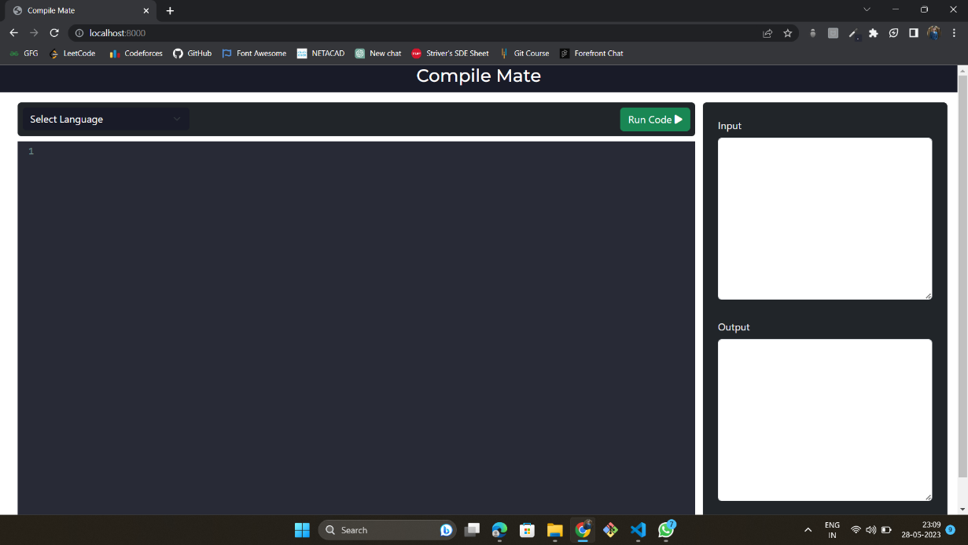

**User Interface**

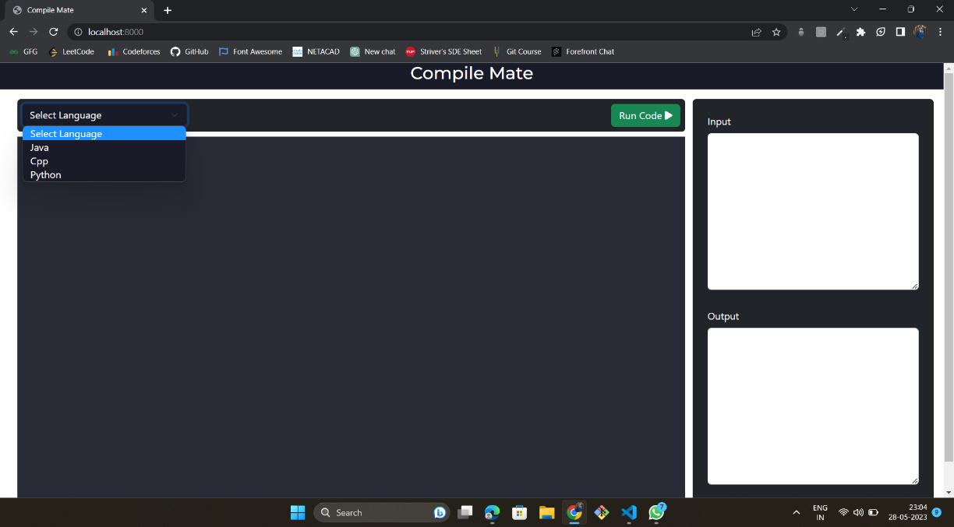

**Language Selection Menu**

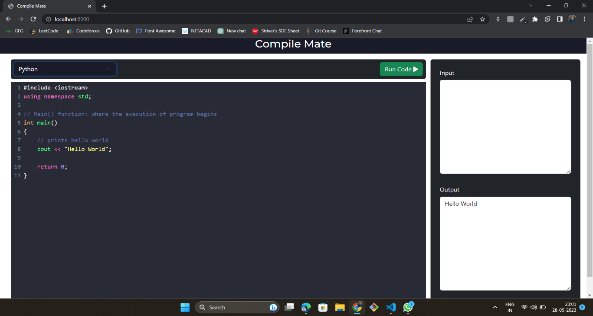

**Python Program 1**

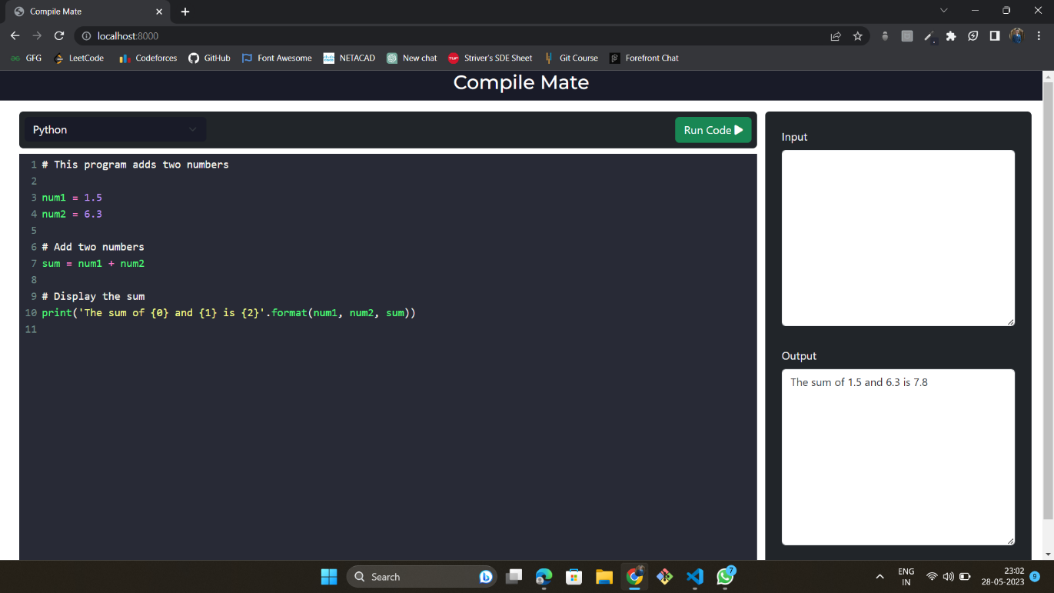

**Python Program 2**

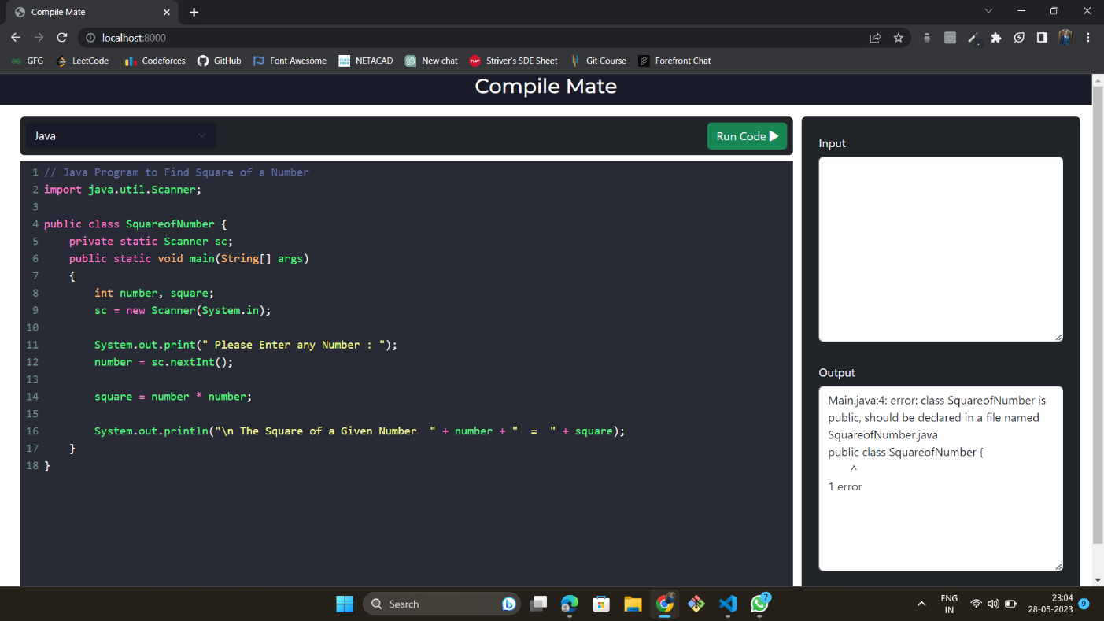

**JAVA Program**

**CHAPTER 8**

**CODING**

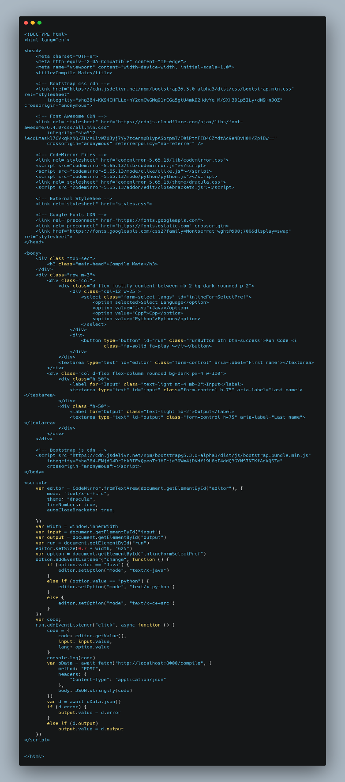

**index.html**

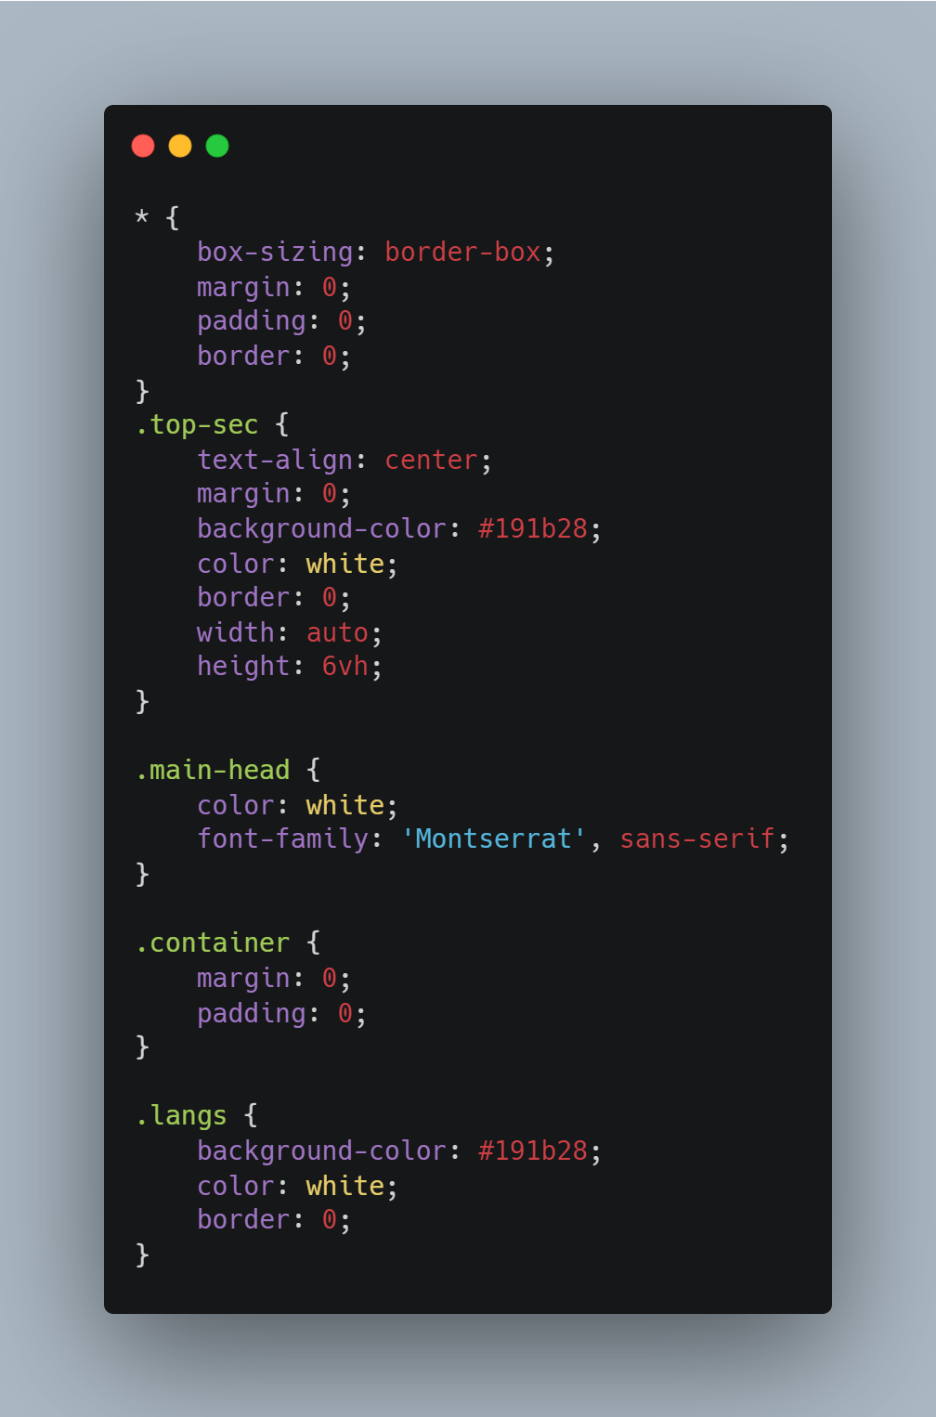

**styles.css**

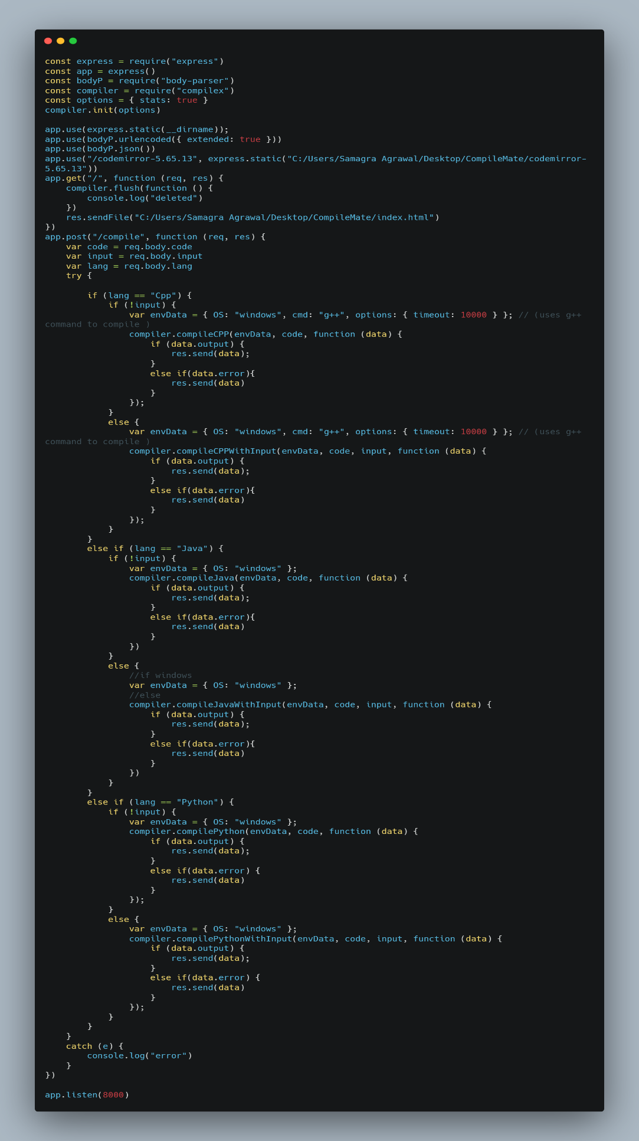

**app.js**

**CHAPTER 9**

**PROJECT LIMITATIONS & FUTURE SCOPE**

**Project Limitations:**

While the "Compile Mate" project aims to deliver a comprehensive and user-friendly online IDE, there are certain limitations to consider. These limitations include:

**1. Language Support:** Initially, "Compile Mate" will focus on supporting a specific set of programming languages. Due to the vast number of programming languages available, it may not cover all languages in its initial release. However, future iterations can expand language support based on user demand and technological feasibility.

**2. Code Execution Complexity:** The code execution capability provided by CodexApi may have certain limitations, such as execution time constraints, resource limitations, or language-specific restrictions. These limitations are inherent to the underlying code execution infrastructure and should be considered when using the "Compile Mate" IDE for running complex or resource-intensive code.

**3. Hardware and Resource Constraints:** The performance and responsiveness of the "Compile Mate" web application can be influenced by the hardware and resource limitations of the hosting environment. In cases where the hardware resources are constrained, the application's ability to handle a large number of concurrent users or resource-intensive tasks might be impacted.

**4. External Service Dependencies:** The "Compile Mate" IDE relies on external services, such as CodexApi for code execution and potentially other third-party services for additional features. Any downtime, API changes, or service disruptions from these external dependencies may affect the overall functionality and availability of the application.

**5. Security Considerations:** While efforts will be made to ensure the security of user data and the application, the "Compile Mate" project may have certain security considerations. Measures should be implemented to prevent unauthorized access, protect user data, and mitigate potential security vulnerabilities. Regular security audits and updates should be performed to address emerging security threats.

**Future Scope:**

The "Compile Mate" project has significant potential for future enhancements and expansions. Some areas of future scope include:

**1. Enhanced Code Editing Features:** Future iterations of "Compile Mate" can incorporate advanced code editing features like code refactoring, intelligent code suggestions, and debugging capabilities. These additions would further improve the productivity and efficiency of developers using the IDE.

**2. Additional Integration Options:** "Compile Mate" can explore integrating with popular code hosting platforms like GitHub, GitLab, or Bitbucket. This integration would allow users to directly access and manage their repositories, create branches, perform code reviews, and synchronize changes within the IDE.

**3. Plugin and Extension Ecosystem:** The development of a plugin and extension ecosystem can provide users with the ability to customize and extend the functionality of "Compile Mate." Developers could create and share plugins for specific programming languages, frameworks, or additional features, further enhancing the capabilities of the IDE.

**4. Mobile Application Development:** The future scope of "Compile Mate" includes developing companion mobile applications for iOS and Android platforms. Mobile apps would allow users to access and work on their projects on the go, providing greater flexibility and accessibility.

**5. Performance Optimization:** Continuous performance optimization efforts can be made to ensure the "Compile Mate" IDE delivers a smooth and responsive user experience, even with large codebases or high user loads. Techniques like caching, code optimizations, and server scalability enhancements can be implemented to improve overall performance.

**6. Learning Resources Integration:** Integrating learning resources such as tutorials, documentation, and coding exercises within the "Compile Mate" IDE can assist users in enhancing their coding skills and knowledge. This addition would create a comprehensive learning environment for developers.

**7. Collaboration Enhancements:** Future iterations of "Compile Mate" can focus on improving collaboration features, including real-time code sharing, pair programming capabilities, and integrated communication channels to facilitate effective teamwork among developers.

By considering these limitations and future scope, the "Compile Mate" project can evolve into a powerful and feature-rich online IDE that meets the evolving needs of developers and enhances their coding experience and productivity.

**CHAPTER 10**

**REFERENCES**

During the development of the "Compile Mate" project, the following references were consulted:

- Node.js Documentation: [https://nodejs.org/en/docs/](https://nodejs.org/en/docs/)

- Express.js Documentation: [https://expressjs.com/](https://expressjs.com/)

- Bootstrap Documentation: [https://getbootstrap.com/docs/](https://getbootstrap.com/docs/)

- CodeMirror Documentation: [https://codemirror.net/doc/](https://codemirror.net/doc/)

- CodexApi Documentation: [https://codexapi.com/docs/](https://codexapi.com/docs/)

These references were valuable in understanding the documentation, APIs, and best practices associated with the technologies used in the project. Additionally, various online forums, tutorials, and academic papers were referenced to gain insights into online IDE development, code execution environments, and related concepts.